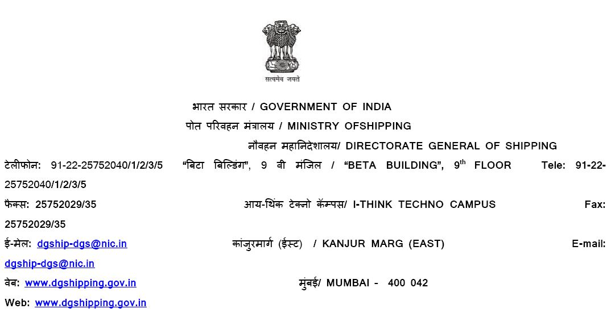
General Information
Name of the Port: | JSW Jaigarh Port Ltd.
Location of the Port:
Type of Port: Major Port, Non-Major Non-Major Port, Repair Port, Dry-dock
Designation of Responsible Person
Contact Address of Responsible Person
Name of the Surveyor Conducting the assessment:
Contact Address of the Surveyor conducting the assessment

1. Port Reception Facility (PRF) available in the Port:
Categories of Waste | Availability
Categories of Waste | Yes | No
MARPOL Annex I
Oily Bilge Water
Oil residues (Sludge)
Oil Tank Washings (Slop)
Dry Ballast Water
Scale and Sludge from Tank Cleanings
Others (Please Specify)

MARPOL Annex II (Category of NLS residue/water mixture for discharge to facility from tank washings)
Category X Substances
Category Y Substances
Category Z Substances
Other, Please Specify
MARPOL Annex IV
Sewage
MARPOL Annex IV
Plastics
Floating dunnage, lining, or packing materials
Ground paper products, rags, glass, metal, bottles, crockery, etc
Cargo residues, paper products, rags, glass, metal, bottles, crockery, etc.
Food waste
Incinerator, ash
Other, Specify

Waste Categories | Yes | No
MARPOL Annex VI
Ozone-depleting substances and equipment containing such substances
Exhaust gas-cleaning residues
Others, please specify with relevant MARPOL Annex

2. Adequacy of Port Reception Facilities: Please confirm the following:

Requirements | Yes | No
Is there an assessment of demand for Port Reception facilities (based on quantities and waste categories received and being requested by users) available?
Is the information regarding waste categories for which reception facilities are being provided readily available to visiting ships? Name of contact person/contractors/fees to be charged displayed on port web-site/relayed to ship by other means prior their arrival.
Are the complaints received by port regarding reception facilities adequately addressed?
Are the complaints registered on IMO GISIS Web-site adequately addressed?
Does the reception facilities provided fully meet the need of ships visiting the ports?
Is it ensured that a fee charged to avail the port reception facilities etc. does not act as a dis-incentive to use the facilities?

3. Environmentally Sound Management of Wastes:
Requirements | Yes | No
Categorization and separation of ship waste into hazardous and non-hazardous waste in accordance with hazardous and other waste rules, 2016
Disposal of hazardous and non-hazardous waste in accordance with hazardous waste Rules 2016 and port procedures.
Is the waste received not defined under hazardous waste rules disposed in accordance with relevant rules?

4. Are the deficiencies/scope of improvement given during last assessment have been addressed within the agreed time period? Yes/No If no Please specify.

5. Details of deficiencies in this assessment
Deficiencies and Scope for improvement with agreed time period for rectification:

Name and Signature of Surveyor Person Name and Signature of Responsible

